WAYNE COUNTY ENGINEER'S OFFICE
SCOTT A. MILLER, P.E., P.S.
WAYNE COUNTY ENGINEER
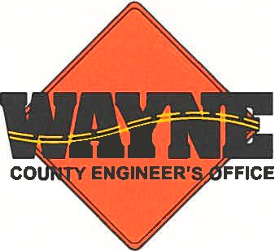

WAYNE COUNTY ENGINEER’S OFFICE

SUMMER HELP

Are you looking for a summer job? Do you enjoy working outdoors?

SUMMER INTERN – Full-time, seasonal position; valid State of Ohio driver’s license with acceptable record; 18 years of age or older. Under direction, the Summer Intern performs unskilled and semi-skilled labor on county roadways, bridges and related areas. Guaranteed 40 hours per week and includes flagging traffic, setting traffic counters, painting, vehicle cleaning and mowing. Pay: $15.00/hr.

Written applications required and accepted until positions are filled at the Wayne County Engineer’s Office, 3151 West Old Lincoln Way, Wooster, Ohio. Office hours are 6:00 AM to 4:30 PM (Mon.-Thur.). Blank applications are also available online at www.wayne-county-engineer.com.

An EOE/Drug-free/ADA compliant employer.

